**CaterSpot Manual**

v

Author: Group_____

**Table of Contents:**

Landing Page ------------------------------------------------------------------------------------- 3

Login Account ------------------------------------------------------------------------------------- 4

Register Account ------------------------------------------------------------------------------------- 5

Catering Services ------------------------------------------------------------------------------------- 8

Cater Gallery ------------------------------------------------------------------------------------- 11

Catering Reservation Process ----------------------------------------------------------------------------- 13

Pre-requisites for Reservation --------------------------------------------------------------------------- 15

Payment Options ------------------------------------------------------------------------------------- 19

Viewing and Canceling Reservations -------------------------------------------------------------------- 21

Printing Invoices ------------------------------------------------------------------------------------- 22

Feedback ------------------------------------------------------------------------------------- 23

**Landing Page**

* link to access caterspot website: <https://caterspot.online/>

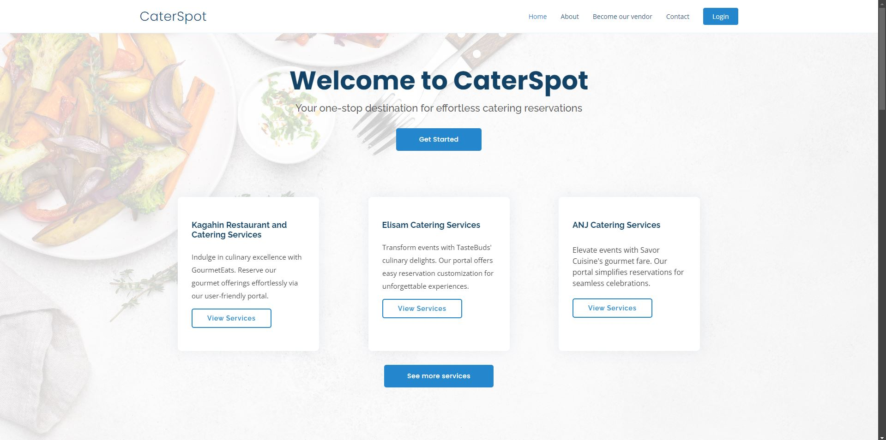

The landing page displays a list of available catering services. Users will find the following navigation options:

* Home
* About
* Become Our Vendor
* Contact
* Login

**Login Account**

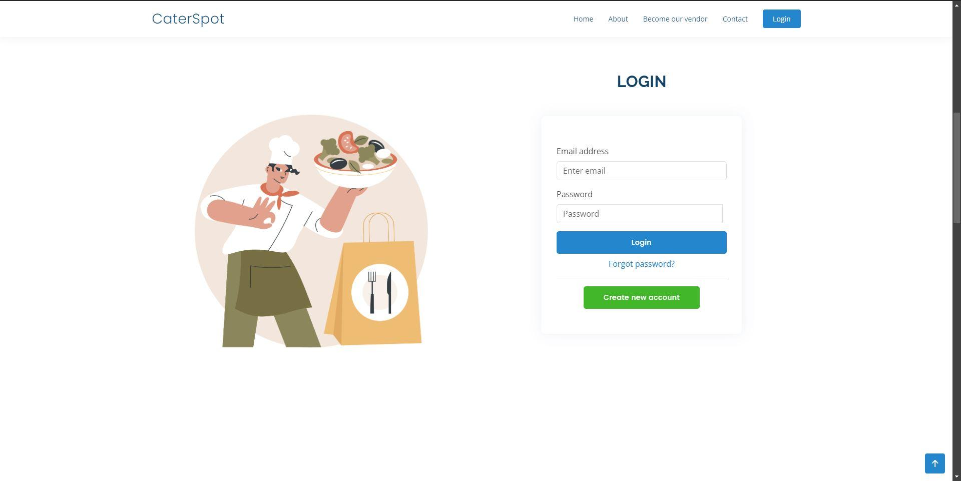

The login page requires users to provide only two pieces of information:

* Email
* Password

**Register Account**

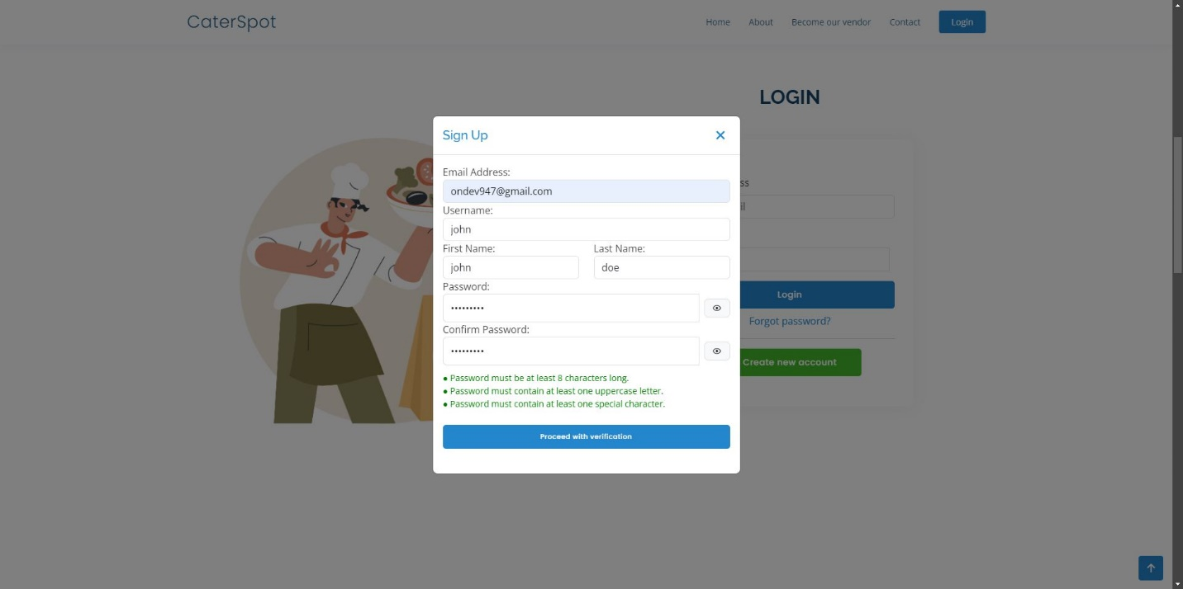

The registration form, accessible via a modal window, requires the following details:

* Email Address
* Username
* First Name
* Last Name
* Password
* Confirm Password

**Password Requirements:**

1. The password must be at least 8 characters long.
2. The password must contain at least one uppercase letter.
3. The password must contain at least one special character.

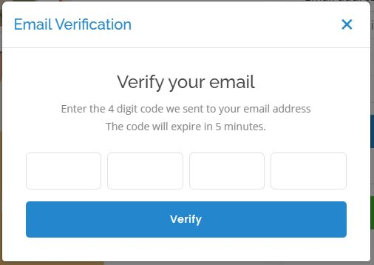

Once the required fields are filled, an email verification code will be sent to the provided email address to verify its authenticity.

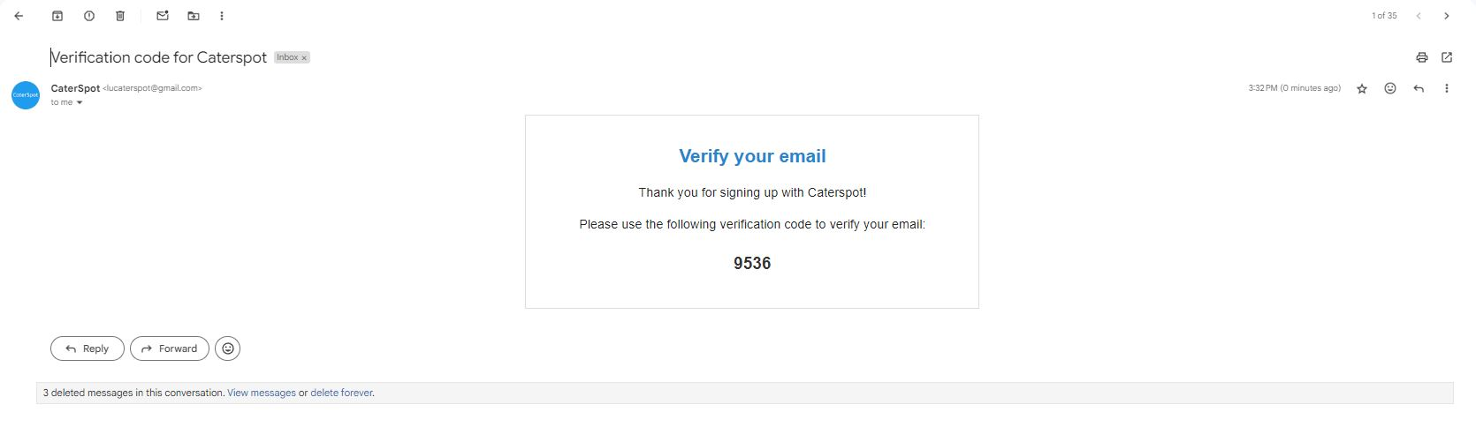

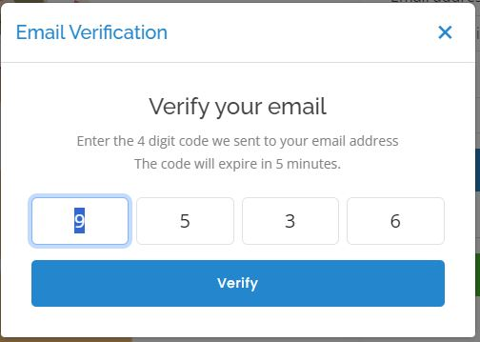

After entering the verification code, the user’s account will be successfully created as a customer on the Caterspot website.

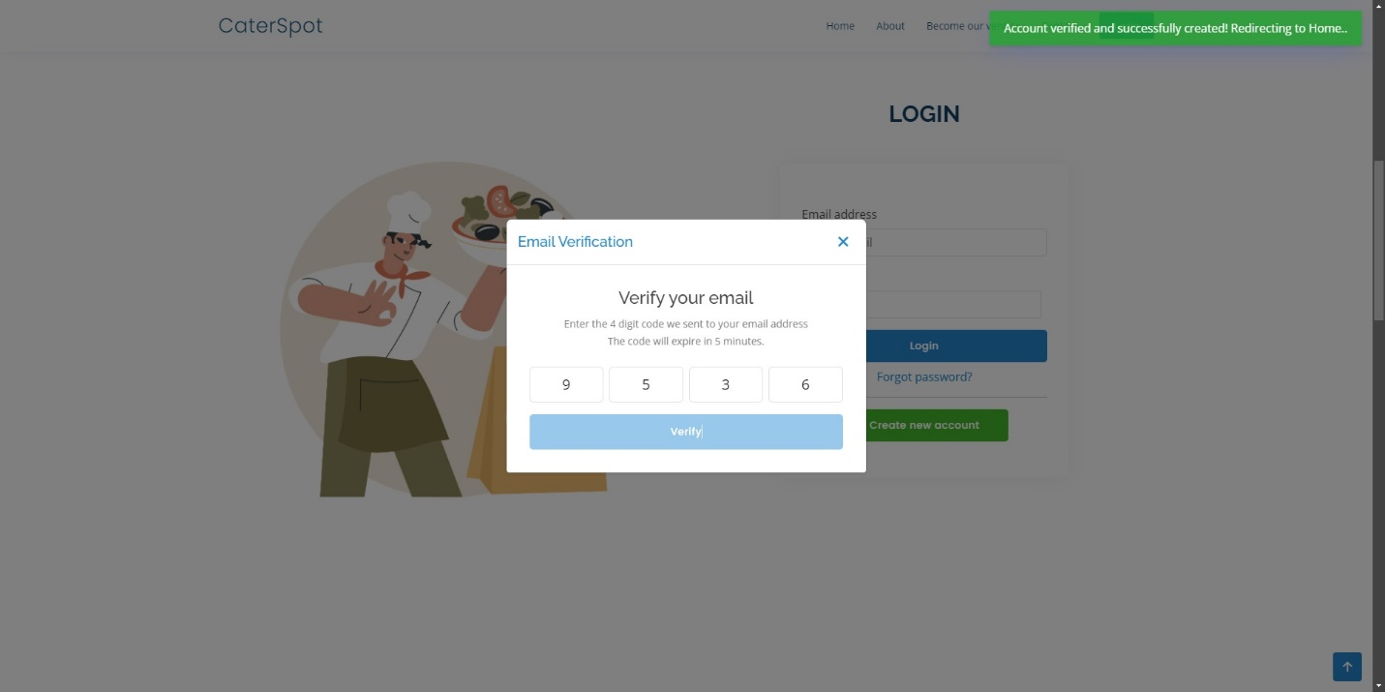

**Catering Services**

To view available catering services, follow these steps:



Click on View Services.

After clicking, you will be directed to a page where you can see catering details such as:

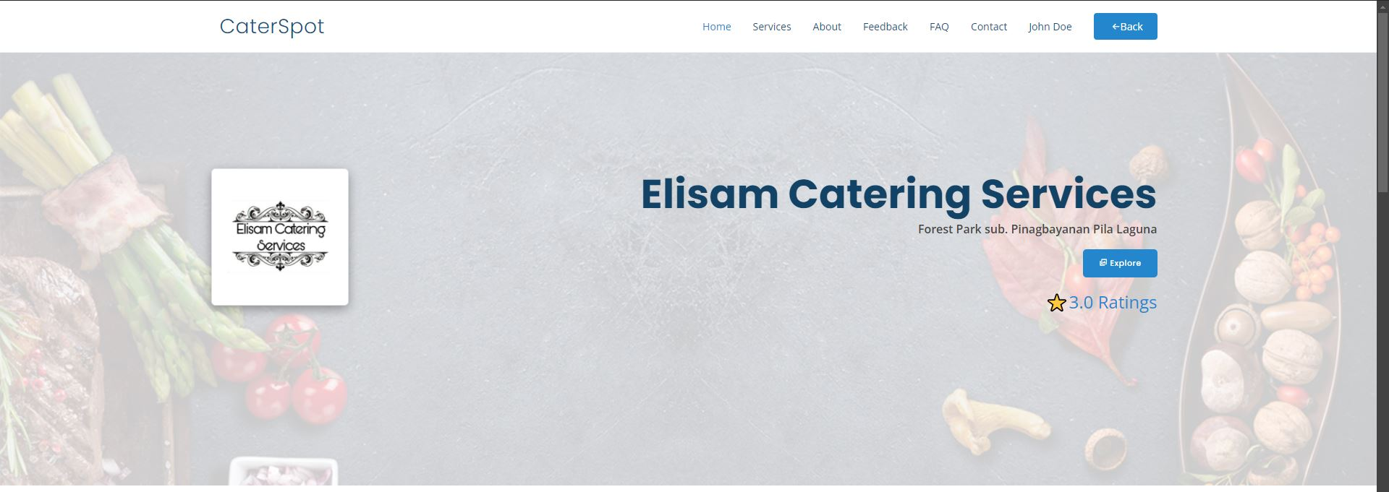

* Name
* Location
* Profile Image
* Ratings

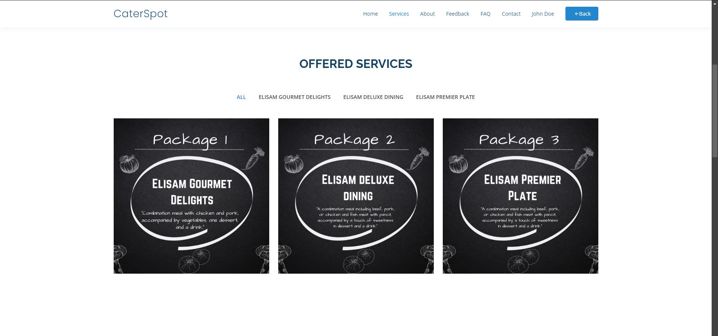

Available catering services will be listed.

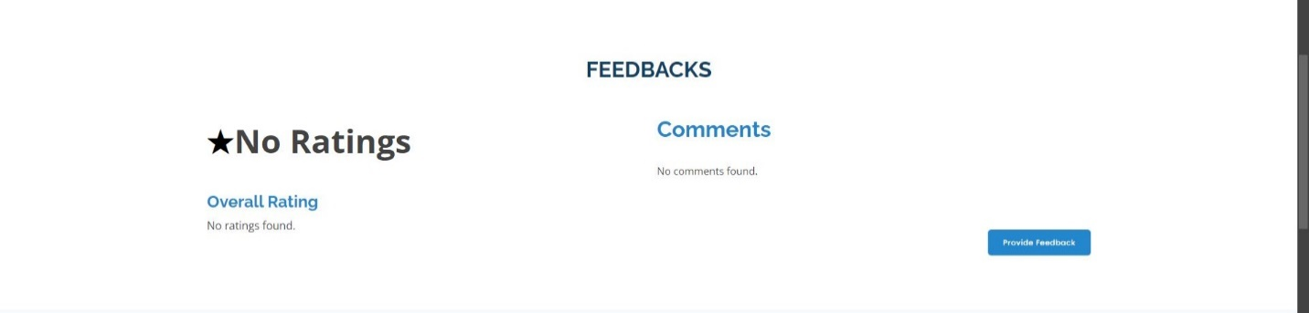

A Ratings and Feedback Section will show customer reviews and feedback.



The FAQ Section will provide answers to frequently asked questions from other customers.

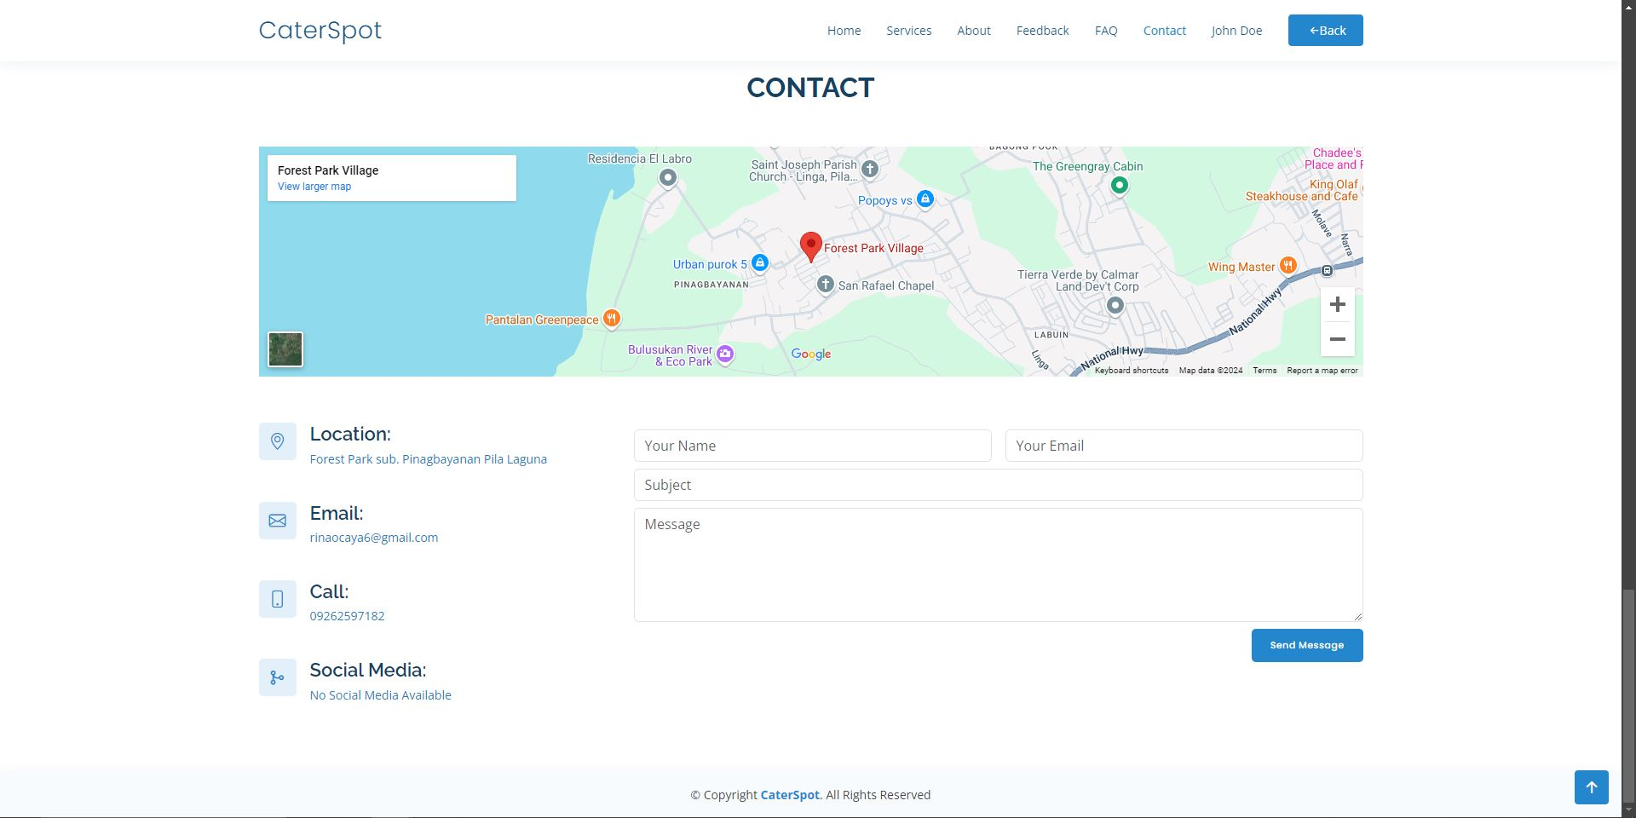

The Contact Section includes the catering services:

* Location
* Email
* Contact Number
* Social Media Profiles
* Google Maps Location

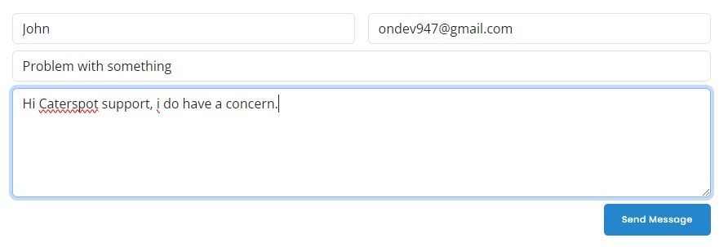

There is also a Send Message to Catering feature, allowing users to directly inquire and communicate with catering personnel.

**Cater Gallery**

To explore the catering gallery:



Click on the Explore button on the landing page.

You will be redirected to a page that stores all images related to the catering services offered.

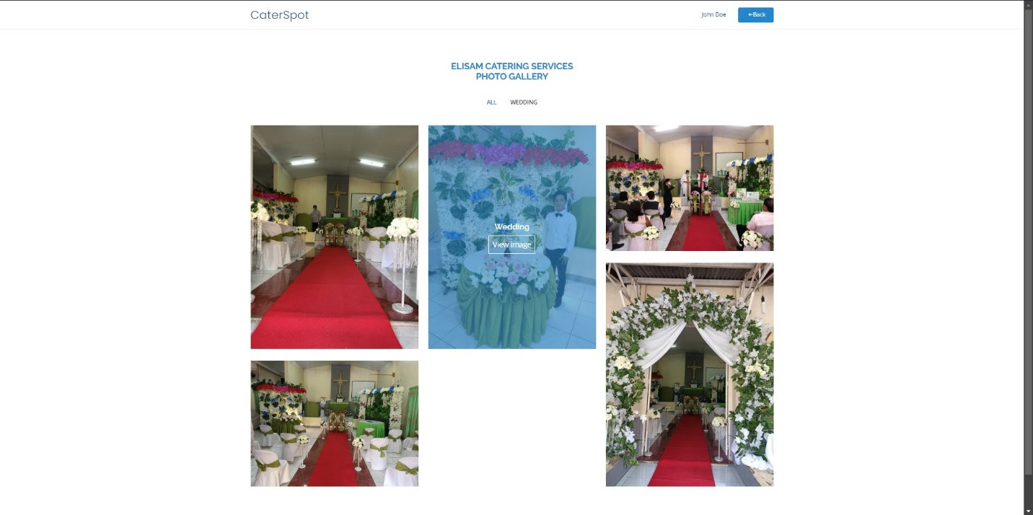

You can view these images by hovering over them and selecting View Image.

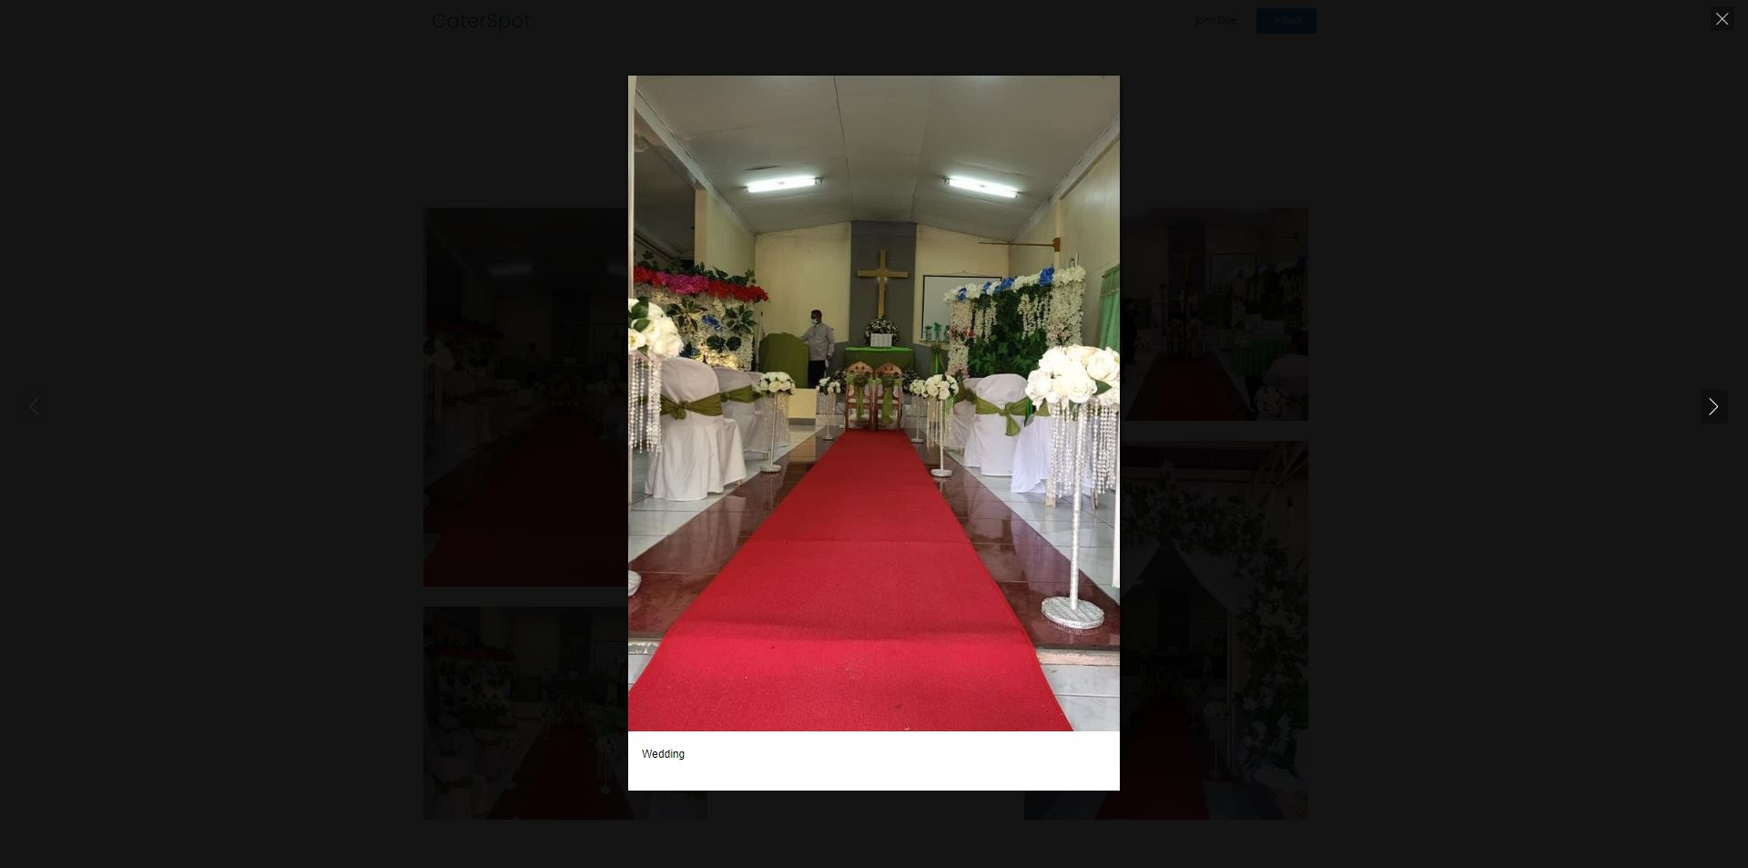

**Catering Reservation Process**

To reserve a catering service:

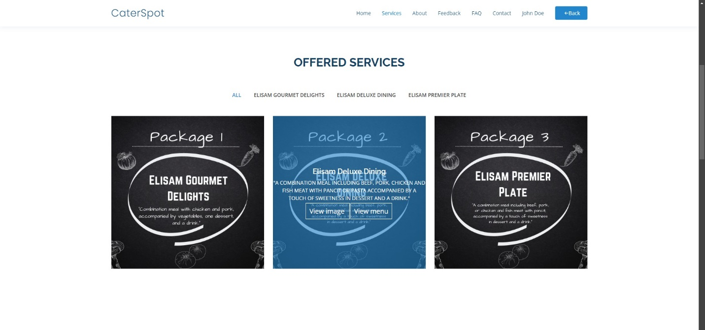

Hover over the services and click View Menu.

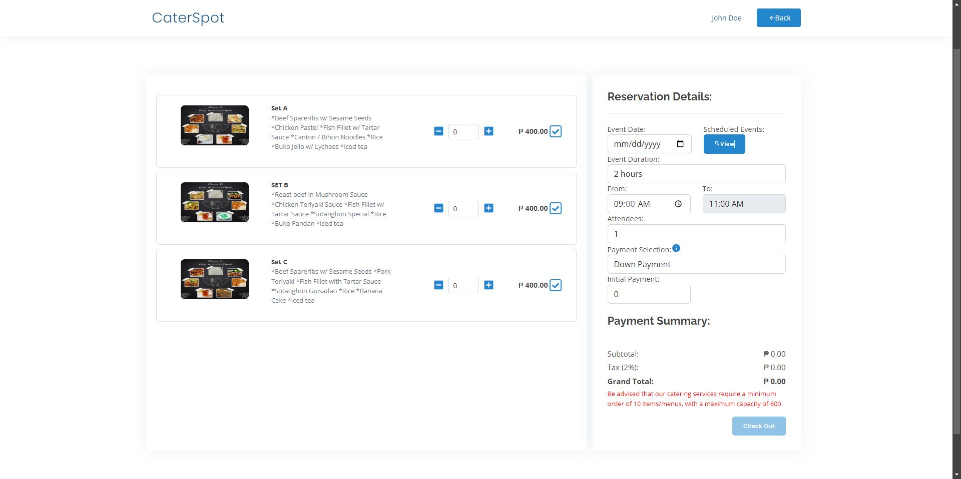

After clicking, you will be directed to a page where you can view the menu packages available for reservation.

The page includes:

* Menu Quantities
* Reservation Details
* Payment Summary

You can also check other customer reservations for specific dates by clicking View Button.

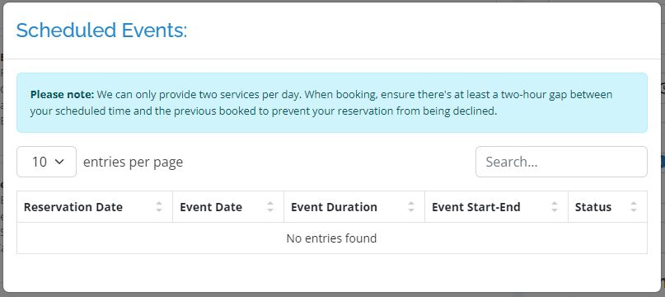

This feature ensures that customers avoid double-booking on the same date. The system allows a maximum of two services per day. If another customer has already booked, you must choose a time with at least a two-hour gap from the previous booking to avoid scheduling conflicts. Failing to comply with this policy will result in reservation cancellation.

**Pre-Requisites for Reservation:**

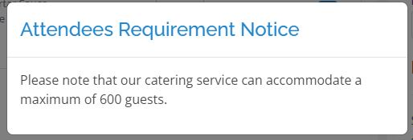

**Attendees Requirement Notice:** The catering service can accommodate up to 600 guests.

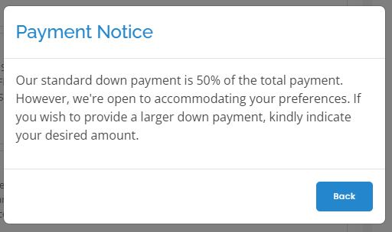

**Payment Notice:** A down payment of 50% of the total amount is required. If you wish to pay more, please indicate your preferred amount.

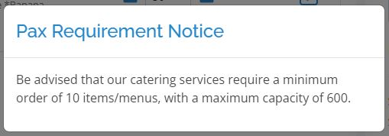

**Pax Requirement Notice:** A minimum of 10 items/menus is required, with a maximum capacity of 600.

**Important Date Restrictions:**

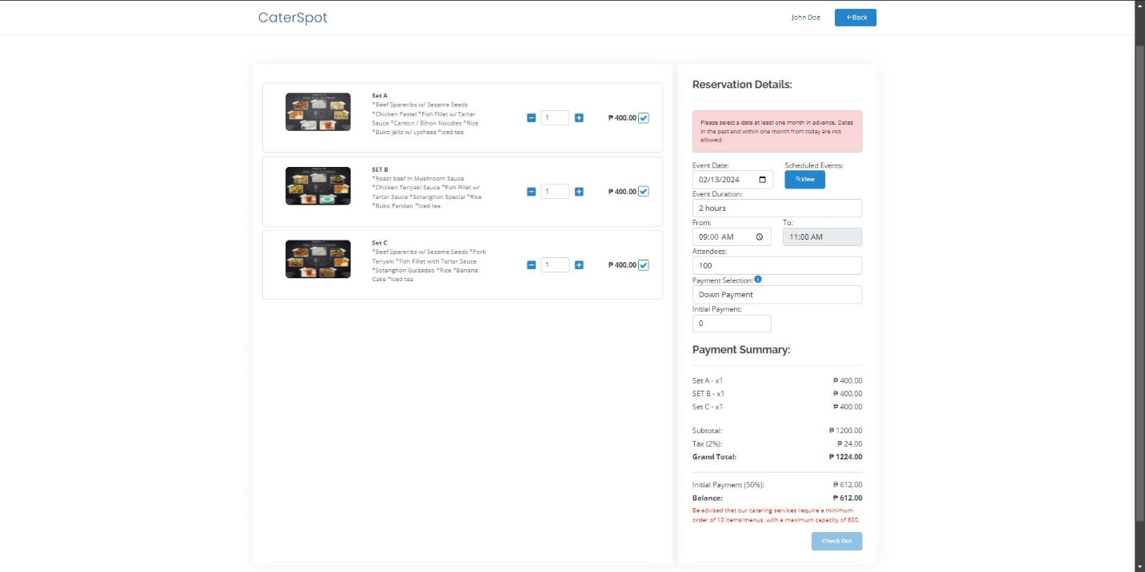

Reservations must be made at least one month in advance.

Dates from the past or within one month from today are not allowed.

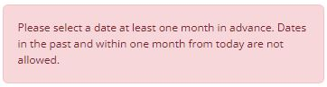

If these conditions are violated, an error message will display: "Please select a date at least one month in advance. Dates in the past and within one month from today are not allowed."

Before proceeding with your reservation, ensure that your address and contact number are updated in your profile. Failure to do so will prevent you from completing the checkout process.

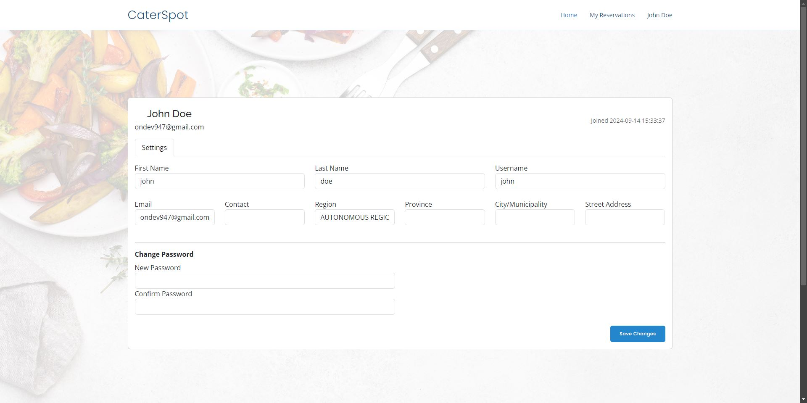

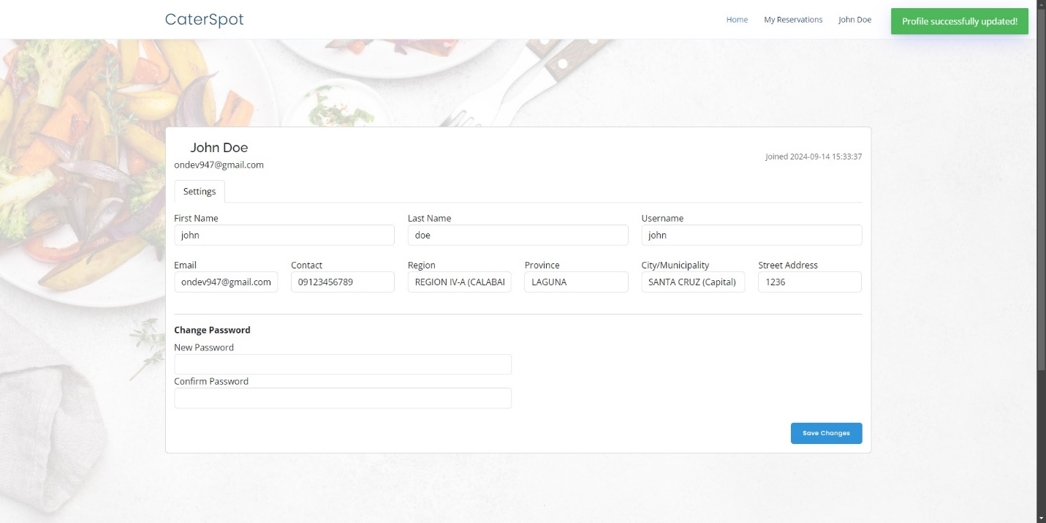

Once your details are updated, and you have filled in all necessary information and selected menus, click the Checkout button.

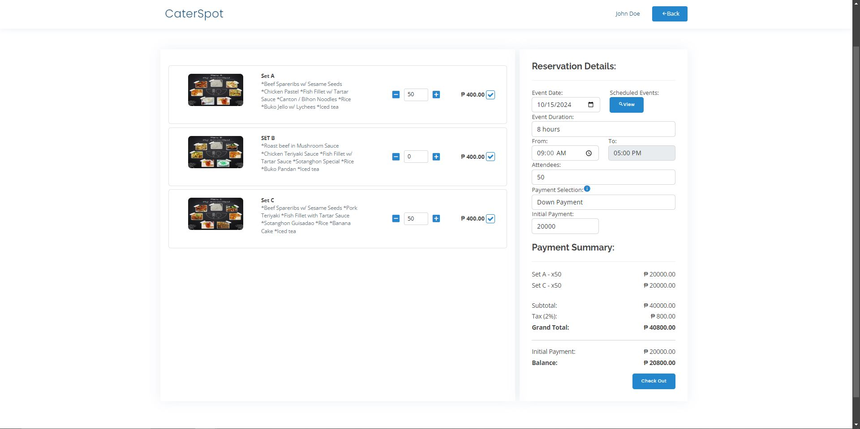

**Payment Options:**

Caterspot offers two payment options:

**Walk-In Cash:** Payment will be made in person at the time of service.

**GCash:** If you select GCash, the catering service’s GCash account number and name will be displayed for payment.

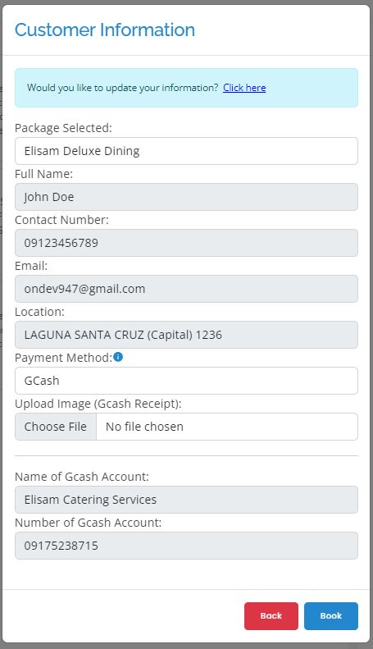

After the reservation is processed, you will be directed to the My Reservations page, where you can monitor your reservations.

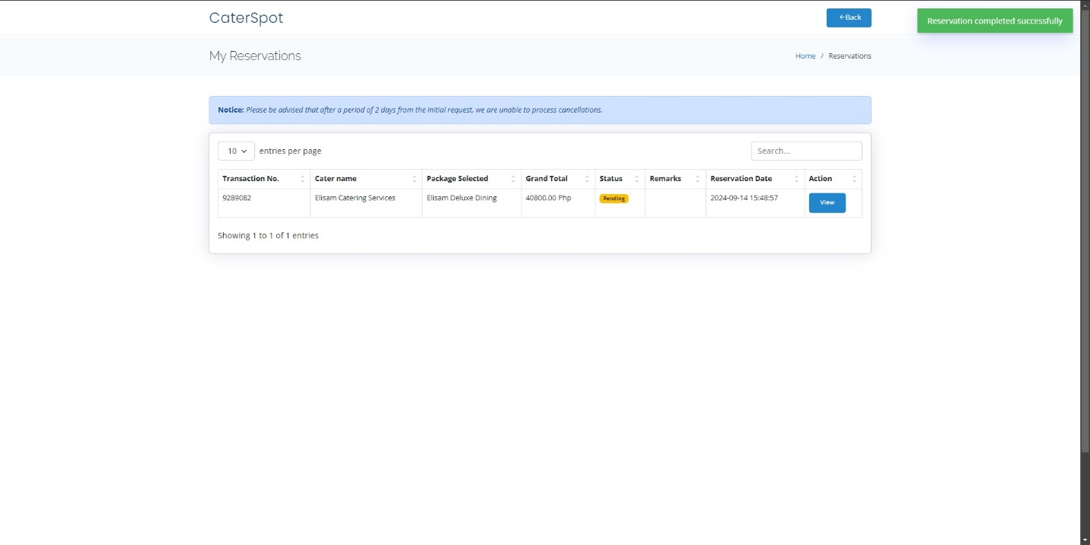

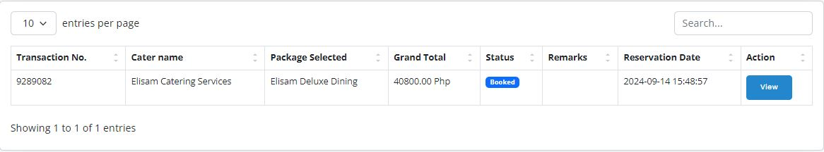

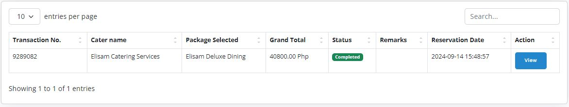

**Reservation statuses include:**

* Pending
* Booked
* Completed
* Rejected

**Viewing and Canceling Reservations**

To view the details of your reservation, click the View button.

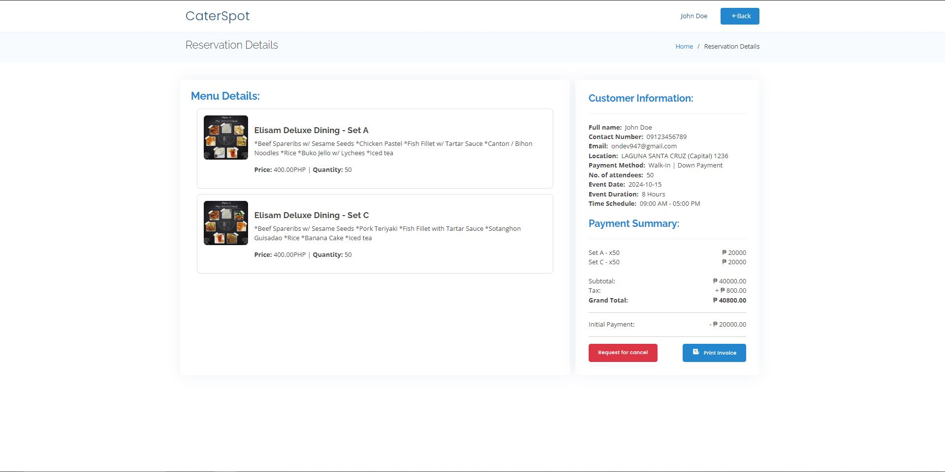

You will also find a Request Cancel button in case you need to cancel due to emergencies. Cancellation requests must include a brief reason, and processing may take 1-2 days.

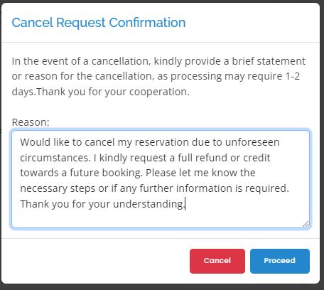

**Printing Invoices**

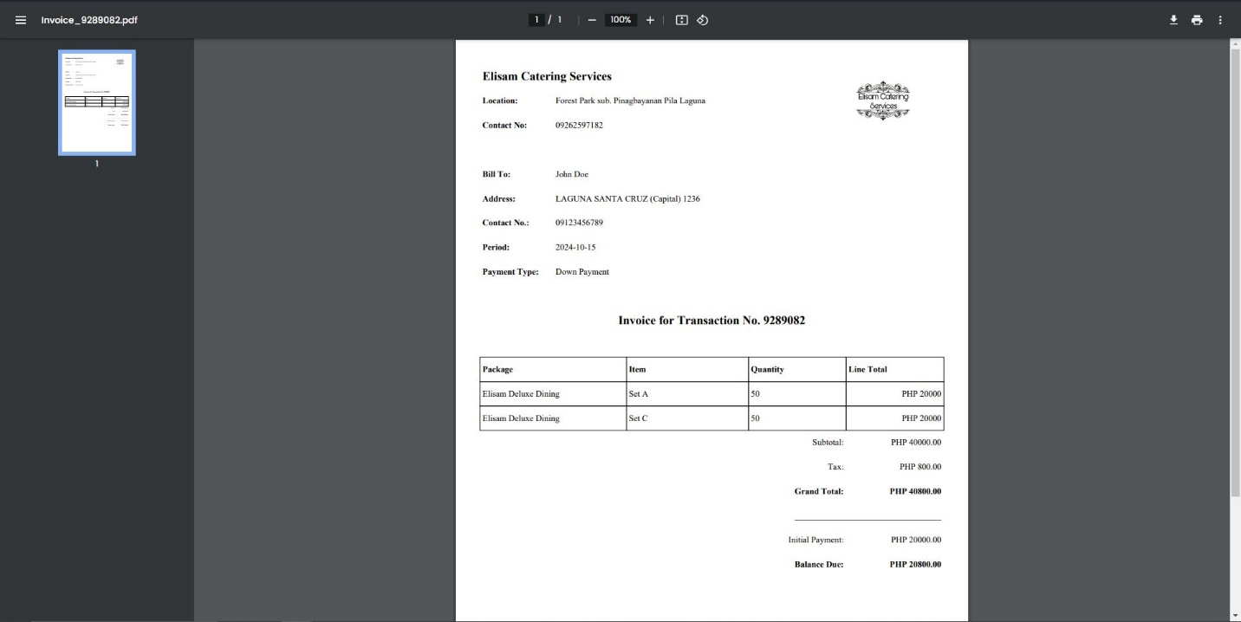

You can print your invoice by clicking the Print Invoice button, which generates a PDF file. This document includes:

* Catering service details (name, location, contact number)
* Bill To details
* Payment Type
* Transaction Number
* Reservation Details (subtotal, tax, grand total, initial payment, and balance due)
* This printed invoice will serve as proof of your reservation when you arrive at the catering venue

**Feedback**

After completing a transaction, customers have the option to provide a review or feedback on the catering service. They can rate the service by selecting a star rating and submitting a comment to share their experience.

